Git advance usage

- Git terminologies
- local repo
- working directory and staging area
- commits
Commit holds the current state of the repository. A commit is also named by SHA1 hash. You can consider a commit object as a node of the linked list. Every commit object has a pointer to the parent commit object. From a given commit, you can traverse back by looking at the parent pointer to view the history of the commit. If a commit has multiple parent commits, then that particular commit has been created by merging two branches.

- branches
- tags
- clone
- pull
- push
- HEAD
HEAD is a pointer, which always points to the latest commit in the branch. Whenever you make a commit, HEAD is updated with the latest commit.
- Revision
- url

- Life cycle

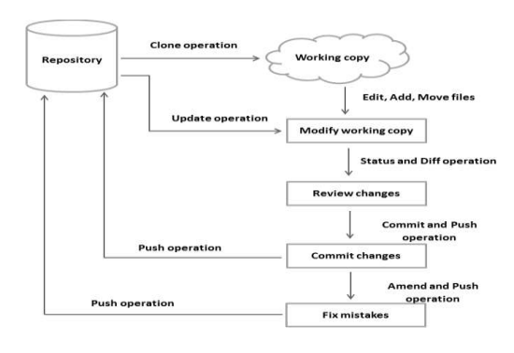

General workflow:
- clone the Git repository as a working copy.(git clone)
- modify the working copy by adding/editing files.(git add)
- If necessary, you also update the working copy by taking other developers' changes.(git fetch, git rebase)
- You review the changes before commit.(git diff)
- You commit changes. If everything is fine, then you push the changes to the repository.(git commit,git push)
- After committing, if you realize something is wrong, then you correct the last commit and push the changes to the repository.(git add, git commit –amend, git push)

- fix mistakes
  - revert uncommitted changes
for the case of modified file from local repo
git checkout
for the case deleted file from local repo
git checkout

  - remove changes from staging area
for the case of modified file from local repom and adds it into the staging aera
git checkout HEAD
this will reset the working tree and also to remove the staging area
NOTE: in git , HEAD pointer always points to the latest commit.
  - move HEAD pointer with git reset

git reset –hard (revert the modified file from staging area and local changes too.)
Git status show the staging areas ‘s status
git diff show the reset operation remove the local changes too.

Git reset –soft
Don’t destroy anything,but reset the head pointer only

Git reset –mix
Reset staging area’s content, but retain working directory’s content
- stash
store your partial changes and later on commit it
In Git, the stash operation takes your modified tracked files, stages changes, and saves them on a stack of unfinished changes that you can reapply at anytime.

- Patch
git format-patch -1 (creat a patch for the latest commit)

git format-patch commit-id (creat patch for a specific commit)

Git provides two commands to apply patches git am and git apply, respectively. Git apply modifies the local files
without creating commit, while git am modifies the file and creates commit as well.
- Cheey-pick→ creat a copy of a changeset
Git cheey-pick commit-id1 commit-id2
- Revert-undo an effect of a commit
Revert one commit, use git revert
Revert all the changes made to the whole working area, use git reset –hard
Revert changes to a single file , use git checkout
- others

